Nama : Afridho Ikhsan

Kelas : 3A-Informatika

NPM : 2210631170002

Mata Kuliah : Pemrograman Berorientasi Objek (PBO)

1. Buatlah Aplikasi Kalkulator seperti berikut :

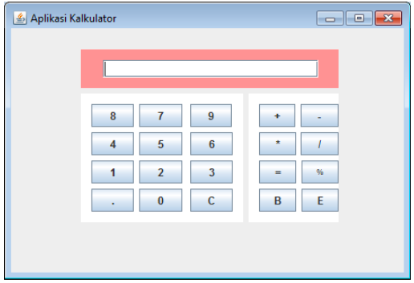

|  |  |
| --- | --- |
|  | Class Kalkulator |
|  | package TugasPertemuan8;  import java.util.ArrayList;  public class Kalkulator extends javax.swing.JFrame {  // Deklarasi variabel  private javax.swing.JTextField fieldAngka;  private javax.swing.JPanel jPanel1;  private javax.swing.JPanel jPanel2;  private javax.swing.JPanel jPanel3;  private javax.swing.JPanel jPanel4;  private javax.swing.JButton tombol0;  private javax.swing.JButton tombol1;  private javax.swing.JButton tombol2;  private javax.swing.JButton tombol3;  private javax.swing.JButton tombol4;  private javax.swing.JButton tombol5;  private javax.swing.JButton tombol6;  private javax.swing.JButton tombol7;  private javax.swing.JButton tombol8;  private javax.swing.JButton tombol9;  private javax.swing.JButton tombolB;  private javax.swing.JButton tombolBagi;  private javax.swing.JButton tombolC;  private javax.swing.JButton tombolE;  private javax.swing.JButton tombolKali;  private javax.swing.JButton tombolKurang;  private javax.swing.JButton tombolPersen;  private javax.swing.JButton tombolSamaDengan;  private javax.swing.JButton tombolTambah;  private javax.swing.JButton tombolTitik;  public Kalkulator() {  initComponents();  }  private void tombolTitikMouseClicked(java.awt.event.MouseEvent evt) {  // TODO add your handling code here:  fieldAngka.setText(fieldAngka.getText()+ ".");  }  private void tombol0MouseClicked(java.awt.event.MouseEvent evt) {  // TODO add your handling code here:  fieldAngka.setText(fieldAngka.getText()+ "0");  }  private void tombolCMouseClicked(java.awt.event.MouseEvent evt) {  // TODO add your handling code here:  fieldAngka.setText("");    }  private void tombol1MouseClicked(java.awt.event.MouseEvent evt) {  // TODO add your handling code here:  fieldAngka.setText(fieldAngka.getText() + "1");  }  private void tombol2MouseClicked(java.awt.event.MouseEvent evt) {  // TODO add your handling code here:  fieldAngka.setText(fieldAngka.getText() + "2");  }  private void tombol3MouseClicked(java.awt.event.MouseEvent evt) {  // TODO add your handling code here:  fieldAngka.setText(fieldAngka.getText() + "3");  }  private void tombol4MouseClicked(java.awt.event.MouseEvent evt) {  // TODO add your handling code here:  fieldAngka.setText(fieldAngka.getText() + "4");    }  private void tombol5MouseClicked(java.awt.event.MouseEvent evt) {  // TODO add your handling code here:  fieldAngka.setText(fieldAngka.getText() + "5");  }  private void tombol6MouseClicked(java.awt.event.MouseEvent evt) {  // TODO add your handling code here:  fieldAngka.setText(fieldAngka.getText() + "6");  }  private void tombol7MouseClicked(java.awt.event.MouseEvent evt) {  // TODO add your handling code here:  fieldAngka.setText(fieldAngka.getText() + "7");  }  private void tombol8MouseClicked(java.awt.event.MouseEvent evt) {  // TODO add your handling code here:  fieldAngka.setText(fieldAngka.getText() + "8");  }  private void tombol9MouseClicked(java.awt.event.MouseEvent evt) {  // TODO add your handling code here:  fieldAngka.setText(fieldAngka.getText() + "9");  }  private void tombolTambahMouseClicked(java.awt.event.MouseEvent evt) {  // TODO add your handling code here:  fieldAngka.setText(fieldAngka.getText() + "+");  }  private void tombolKurangMouseClicked(java.awt.event.MouseEvent evt) {  // TODO add your handling code here:  fieldAngka.setText(fieldAngka.getText() + "-");  }  private void tombolKaliMouseClicked(java.awt.event.MouseEvent evt) {  // TODO add your handling code here:  fieldAngka.setText(fieldAngka.getText() + "*");  }  private void tombolBagiMouseClicked(java.awt.event.MouseEvent evt) {  // TODO add your handling code here:  fieldAngka.setText(fieldAngka.getText() + "/");  }  private void tombolPersenMouseClicked(java.awt.event.MouseEvent evt) {  // TODO add your handling code here:  fieldAngka.setText(fieldAngka.getText() + "%");  }  private void tombolSamaDenganMouseClicked(java.awt.event.MouseEvent evt) {  // TODO add your handling code here:  String[] input = fieldAngka.getText().split("[+%-]");  ArrayList<Character> operators = new ArrayList<Character>();  for (int i = 0; i < fieldAngka.getText().length(); i++) {  char currentChar = fieldAngka.getText().charAt(i);  if (currentChar == '+' || currentChar == '-' || currentChar == '%') {  operators.add(currentChar);  }  }  System.out.println(operators);  double result = perhitunganPerkalianDanPembagian(input[0]);  for (int j = 0; j < operators.size(); j++) {  double nextOperand = perhitunganPerkalianDanPembagian(input[j + 1]);  switch (operators.get(j)) {  case '+':  System.out.println("Tambah");  result += nextOperand;  break;  case '-':  result -= nextOperand;  System.out.println("Kurang");  break;  case '%':  result %= nextOperand;  System.out.println("Modulus");  break;  default:  break;  }  }  private double perhitunganPerkalianDanPembagian(String expression) {  String[] factors = expression.split("[*/]");  ArrayList<Character> operators = new ArrayList<Character>();  for (int i = 0; i < expression.length(); i++) {  char currentChar = expression.charAt(i);  if (currentChar == '*' || currentChar == '/') {  operators.add(currentChar);  }  }  double result = Double.parseDouble(factors[0]);  for (int j = 0; j < operators.size(); j++) {  double nextFactor = Double.parseDouble(factors[j + 1]);  switch (operators.get(j)) {  case '*':  System.out.println("Kali");  result *= nextFactor;  break;  case '/':  if (nextFactor != 0) {  result /= nextFactor;  System.out.println("Bagi");  }  break;  default:  break;  }  }  return result;  }  public static void main(String args[]) {  try {  for (javax.swing.UIManager.LookAndFeelInfo info : javax.swing.UIManager.getInstalledLookAndFeels()) {  if ("Nimbus".equals(info.getName())) {  javax.swing.UIManager.setLookAndFeel(info.getClassName());  break;  }  }  } catch (ClassNotFoundException ex) {  java.util.logging.Logger.getLogger(Kalkulator.class.getName()).log(java.util.logging.Level.SEVERE, null, ex);  } catch (InstantiationException ex) {  java.util.logging.Logger.getLogger(Kalkulator.class.getName()).log(java.util.logging.Level.SEVERE, null, ex);  } catch (IllegalAccessException ex) {  java.util.logging.Logger.getLogger(Kalkulator.class.getName()).log(java.util.logging.Level.SEVERE, null, ex);  } catch (javax.swing.UnsupportedLookAndFeelException ex) {  java.util.logging.Logger.getLogger(Kalkulator.class.getName()).log(java.util.logging.Level.SEVERE, null, ex);  }  /* Membuat dan Menampilkan kalkulator*/  java.awt.EventQueue.invokeLater(new Runnable() {  public void run() {  new Kalkulator().setVisible(true);  }  });  }  } |

Output Program:

* Sebelum dijalankan

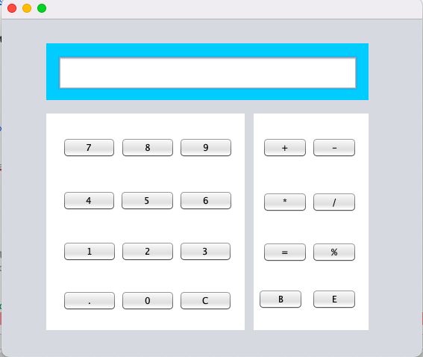

* Saat digunakan

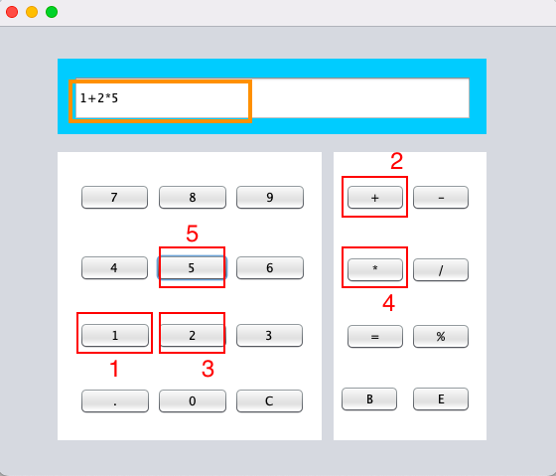

* Setelah dijalankan

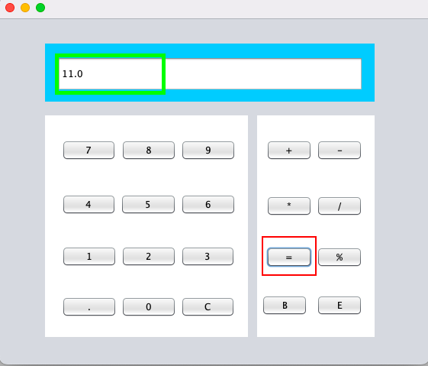



1. Buatlah tampilan seperti berikut (PenentuJumlahHari.java) :

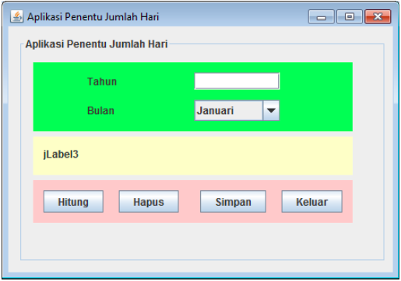

Dengan ketentuan sebagai berikut :

a. Buatlah sebuah class HitungHari yang mempunyai method hitung() yang

berfungsi untuk melakukan proses untuk mendapatkan jumlah hari dari

inputan yang di berikan oleh user (Tahun dan Bulan)

b. Panggil method Hitung() tersebut pada class PenentuJumlahHari.java

c. Button hapus berfungsi untuk mengosongkan tahun, bulan dan juga hasil

perhitungan

d. Tombol Simpan berfungsi untuk menyimpan hasil perhitungan ke dalam bentuk

.txt

e. Hasil ketika di running

|  |  |
| --- | --- |
|  | Class HitungHari |
|  | package TugasPertemuan11;  import java.util.Scanner;  public class HitungHari {  public int hitung(int tahun, int bulan) {  // Hitung jumlah hari  int jumlahHari = hitungJumlahHari(tahun, bulan + 1);  // Return hasil  return jumlahHari;  }  private int hitungJumlahHari(int tahun, int bulan) {  switch (bulan) {  case 1: case 3: case 5: case 7: case 8: case 10: case 12:  return 31;  case 4: case 6: case 9: case 11:  return 30;  case 2:  // Cek apakah tahun adalah tahun kabisat  if ((tahun % 4 == 0 && tahun % 100 != 0) || (tahun % 400 == 0)) {  return 29; // Tahun kabisat, bulan Februari memiliki 29 hari  } else {  return 28; // Bukan tahun kabisat, bulan Februari memiliki 28 hari  }  default:  return -1; // Bulan tidak valid  }  }  } |

|  |  |
| --- | --- |
|  | Class PenentuJumlahHari |
|  | package TugasPertemuan11;  import javax.swing.JOptionPane;  import java.io.BufferedWriter;  import java.io.FileWriter;  public class PenentuJumlahHari extends javax.swing.JFrame {  // Deklarasi variable component  private javax.swing.JComboBox<String> bulan;  private javax.swing.ButtonGroup buttonGroup1;  private javax.swing.JLabel hasil;  private javax.swing.JLabel jLabel2;  private javax.swing.JLabel jLabel3;  private javax.swing.JPanel jPanel1;  private javax.swing.JPanel jPanel2;  private javax.swing.JPanel jPanel3;  private javax.swing.JPanel jPanel4;  private javax.swing.JLabel judulProgram;  private javax.swing.JTextField tahun;  private javax.swing.JButton tombolHapus;  private javax.swing.JButton tombolHitung;  private javax.swing.JButton tombolKeluar;  private javax.swing.JButton tombolSimpan;    public PenentuJumlahHari() {  initComponents();  }  private void tombolHapusMouseClicked(java.awt.event.MouseEvent evt) {  // TODO add your handling code here:  tahun.setText("");  bulan.setModel(new javax.swing.DefaultComboBoxModel<>(new String[] { "Januari", "Februari", "Maret", "April", "Mei", "Juni", "Juli", "Agustus", "September", "Oktober", "November", "Desember" }));  hasil.setText("");  }  private void tombolKeluarMouseClicked(java.awt.event.MouseEvent evt) {  // TODO add your handling code here:  int reply = JOptionPane.showConfirmDialog(null, "Yakin ingin keluar?", "Konfirmasi Keluar Aplikasi", JOptionPane.YES_NO_OPTION);    if(reply == JOptionPane.YES_OPTION){  System.exit(0);  }else{  tahun.requestFocus();  }  }  private void tombolSimpanMouseClicked(java.awt.event.MouseEvent evt) {  // TODO add your handling code here:  try{  BufferedWriter out = new BufferedWriter(new FileWriter("/Users/macbookair/Downloads/hitungnilai.txt"));  String result = hasil.getText();  out.write(result);    JOptionPane.showMessageDialog(null, "Berhasil disimpan dalam file");  out.close();  }catch (Exception e){  System.err.println("Error : "+e.getMessage());  }  }  private void tombolHitungMouseClicked(java.awt.event.MouseEvent evt) {  // TODO add your handling code here:  HitungHari kalkulasi = new HitungHari();    String inputTahun = tahun.getText();  int indexInputBulan = bulan.getSelectedIndex();    int tahun = Integer.parseInt(inputTahun);  int indexBulan = indexInputBulan;    int jumlahHari = kalkulasi.hitung(tahun, indexBulan);    hasil.setText("Jumlah hari pada bulan " + bulan.getSelectedItem() + " tahun " + inputTahun+ " adalah "+jumlahHari );  }  public static void main(String args[]) {  java.awt.EventQueue.invokeLater(new Runnable() {  public void run() {  new PenentuJumlahHari().setVisible(true);  }  });  }  } |

Output program:

* Sebelum dilakukan perhitungan

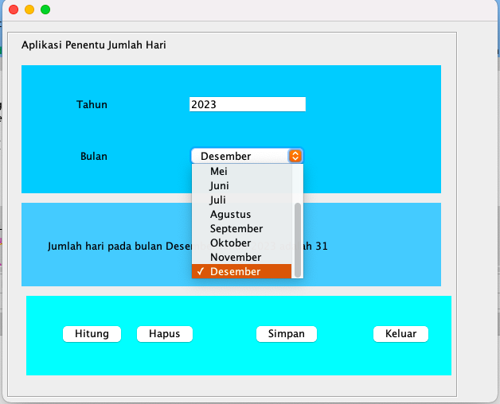

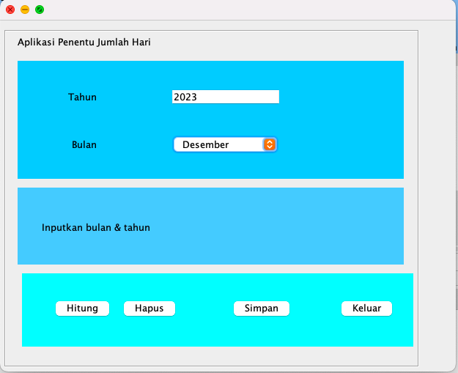



* Setelah dilakukan perhitungan

